**DATA ANALYSIS REPORT**

**Introduction**

From the analysis of the DVD rental data, important insights were identified and which the management of the rental firm can utilized.

**First Insight: Top 10 Popular Film**

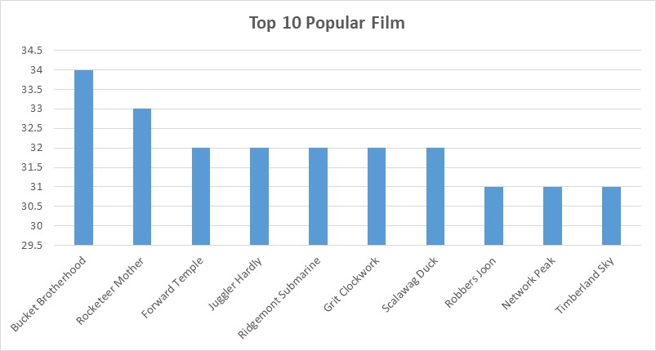

The analysis of the DVD rental films revealed the films that are most populous that people are willing to rent. The figure above showcases the list of the first 10 most populous films rented within the same period where Bucket Brotherhood and Rocketeer Mother happen to be the most rented and populous films rented.

**Second Insight: Top 10 Categories of Film Rented**

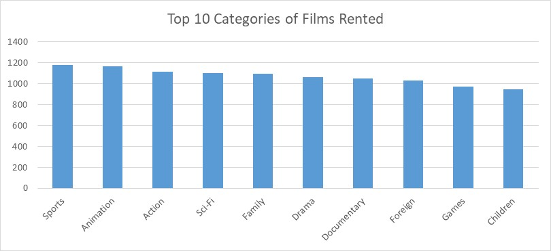

From the analysis of the DVD Rental data set, it is discovered that Sport, Animation and Action films are mostly rented. This indicates strong customer preferences which requires the manager to focus on making those most rented categories of films available to increase purchase and profitability.

**Third Insight: Rental Trends**

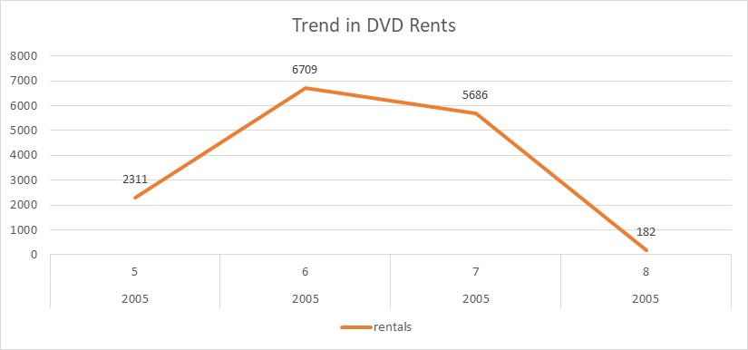

From the analysis carried out, it is obvious that the DVD rents increased between the fifth month of 2005 and the six month of the same years whereas it began to reduce from the seventh month till the second month of 2006. Thus, this could be as a result of the inception of social media platforms and series of streaming platforms to watch videos.

**Fourth Insight: Overdue Pattern**

From the analysis, it is obvious that animation, action and sport films are the most delayed films to be returned back to the store after being rented. Animation film has the highest level of overdue follow by action films and sport films. Whereas, travel and music films are the least overdue films.

**Recommendations:**

1. **Increase Stock of Popular Films and Genres**: Given the popularity of films like *Bucket Brotherhood* and *Rocketeer Mother*, the store should maintain or increase its stock of these titles. Additionally, since *Sport*, *Animation*, and *Action* films are in high demand, consider expanding the inventory in these genres.
2. **Implement Seasonal Marketing Strategies**: The spike in rentals between the 5th and 6th months suggests that there may be an opportunity to capitalize on seasonal trends. The store should plan promotional activities around these high-demand periods, offering discounts or special deals to boost rentals further. During slower months, consider offering loyalty programs to encourage consistent rentals.
3. **Adjust Late Return Policies for Key Genres**: Since *Animation*, *Action*, and *Sport* films are often returned late, the store could revise its late fee structure for these genres or offer incentives for timely returns. Additionally, providing a more flexible rental period for these genres might reduce the overdue rate.
4. **Focus on Genres with Lower Overdue Rates**: Since *Travel* and *Music* films are returned on time more often, the store could consider offering more of these films in the short-term rental category. These genres could be targeted toward customers who prefer shorter rental periods and are more punctual in returns.
5. **Introduce Customer Education or Reminders**: Implement automated reminders through SMS or email for customers renting *Animation*, *Action*, and *Sport* films to return them on time. This could help reduce the number of late returns.
6. **Consider Offering Digital Rentals**: Given the fluctuations in rental activity, the store could explore offering digital rentals as an alternative. This could help maintain steady revenue during slower months and reduce issues related to delayed returns.

**DATABASE SCHEMA ANALYSIS**

**1. film**

**Purpose:** Stores information about each film in the inventory.

**Primary Key:** film_id

**Relationships:**

* It is linked with film_category, in which it categorise films
* It is linked with inventory, which it track the physical copies of the film
* It is also liked with language, which it stores the language of the film

**2. category**

**Purpose:** Stores information about each film in the inventory.

**Primary Key:** category_id

**Relationships:**

* It is linked to film_category, which maps films to categories

**3. film_category**

**Purpose:** A junction table that connects films and categories, representing the many-to-many relationships between them.

**Primary Key:** It has composite key (film_id, category_id)

**Foreign Keys:** film (film_id), category (category_id)

**Relationships:**

* The table links each fil to one or more categories.

**4. inventory**

**Purpose:** Tracks the physical copies or inventory of each film.

**Primary Key:** inventory_id

**Foreign Keys:** film (film_id), store (store_id)

**Relationships:**

* It linked to film and store to track where physical copies are stored
* It linked to rental, since rentals are made for each inventory item.

**5. rental**

**Purpose:** Store information about each rental transaction.

**Primary Key:** rental_id

**Foreign Keys:** inventory (inventory_id), customer (customer_id), staff (staff_id)

**Relationships:**

* It linked to inventory to track what was rented.
* It linked to customer and staff for transaction details

**6. customer**

**Purpose:** Stores information about customers.

**Primary Key:** customer_id

**Foreign Keys:**  store **(**store_id)

**Relationships:**

* It linked to rental to track rental transactions.

**7. staff**

**Purpose:** Stores information about the staff members.

**Primary Key:** staff_id

**Foreign Keys:**  store **(**store_id), address (address_id)

**Relationships:**

* It linked to rental to track which staff member processed a rental.

**8. store**

**Purpose:** Stores information about the stores where films are rented.

**Primary Key:** store_id

**Foreign Keys:**  staff **(**staff_id), address (address_id)

**Relationships:**

* It linked to the staff member managing the store

**9. address**

**Purpose:** Stores addresses for customers, staff, and stores.

**Primary Key:** address_id

**Relationships:**

* It linked to customer, staff, and store to store their physical addresses.

**10. payment**

**Purpose:** Stores payment information for each rental transaction

**Primary Key:** payment_id

**Foreign Keys:**  customer (customer_id), staff (staff_id), rental (rental_id)

**Relationships:**

* It linked to rental, customer, and staff to track payment information.

**11. language**

**Purpose:** Stores the language in which films are available.

**Primary Key:** language_id

**Relationships:**

* It linked to film to indicate the language of each film.

12. actor

**Purpose:** Stores information about the actors that appear in the films.

**Primary Key:** actor_id

**Relationships:**

* It linked to the film_actor table, which associates actors with films.

**13. film_actor**

**Purpose:** A junction table connects films and actors, representing many-to-tomany relationship between films and actors.

**Primary Key:** It has composite key (actor_id, film_id)

**Foreign Keys:**  actor (actor_id), film (film_id)

**Relationships:**

* This table links each actor to one or more films, indicating which actors starred in which films.
* It enables a many-to-many relationships where film can have multiple actors, and an actor can appear in multiple films.

14. city

**Purpose:** Stores information about cities, which are associated with addresses.

**Primary Key:** city_id

**Foreign Keys:**  country (country_id)

**Relationships:**

* It linked address through the city_id, as each address is located in a city.
* Linked to the country table through the country_id, to associate each with a country.

15. country

**Purpose:** Stores information about countries, which are linked to cities.

**Primary Key:** country_id

**Relationships:**

* It linked to city through the country_id, so that cities are associated with their respective countries.